Baruch College, 7-15-20 correction of Ex 1.3, added “)” Prof. L. Tatum
STA/CIS 3020: Exercise 1
Reading Assignment 1

The purpose of Lecture Note 1 is to gather lots of reference material into one place. For the first assignment, just read pages 1-5 and pages 10-11 (on how to save the Workspace). We will refer back to remaining sections as needed.

Guide to Preparing the Exercises
I expect the Exercises to be done at a high level. This is not “homework” in the ordinary sense, since a majority of your grade will based on the Exercises. Treat these assignments as seriously as you would an exam ... in a course that really mattered to you.
As you work, consider this scenario: a few months from now you learn you have an interview for a job on the next day and the company wants you to be prepared show what you know about R and what documentation you can show them of work you, yourself, have done in R. Would you want to have written an ordinary homework, one of those cut-all-corners affairs in which the goal is to minimize time, borrow answers from other students, and avoid any personal involvement? No, of course not. You would want to be in possession of a set of documents about R in which you had put your best effort and could now reap the benefits!
In this course, you are asked to create documents which can be read and understood by a third party who might actually offer you a job if you write well enough.
As you prepare the Exercises, explain what you are doing. Describe the pitfalls you encounter and the solutions you find. Any genuine encounter with software will generate error messages. If you take the error messages seriously and explore the issues involved, you will learn a great deal. And, then you will have something tangible to describe to your reader. It is precisely when software gets really annoying that you are getting close to learning something important. Work it out, discuss what happened, and then your reader will learn something, too. And, perhaps learn to trust you.

Eight Pointers

First: Do not show any of the material on the first two pages of this document in your Exercise 1. To be as clear as I can, I do not want to read this sentence in your submitted Exercise #1.
In your Exercises, do include the highlighted question numbers and headers, and show the question lettering: (a), (b), etc. Please do NOT show the text of the questions. Instead of showing the questions, respond to the questions in complete sentences in such as way that you communicate to the reader what you are about.
If asked to make a graph, do not show me the question I wrote and then your graph. Instead, say something like this: “I am now going to show how to create a graph of .......”. “I am going use the R command ...... which takes arguments ....”. “The reason for making such a graph is to ...” And so on! Treat your reader like a human being, not a Scan Tron Device.

Second: Prepare your document in Microsoft Word. The business offices of the world are run using Microsoft Office.

Third: To show your R commands, use screenshots to capture them, paste those into your Word document, then crop them, cleanly, and adjust and size them to leave room to type on either the right or left side your description of what you were doing, why, and what you found. To crop a screenshot after pasting it into Word when using a Windows computer,
(a) Right click on the screenshot and open Format Picture;
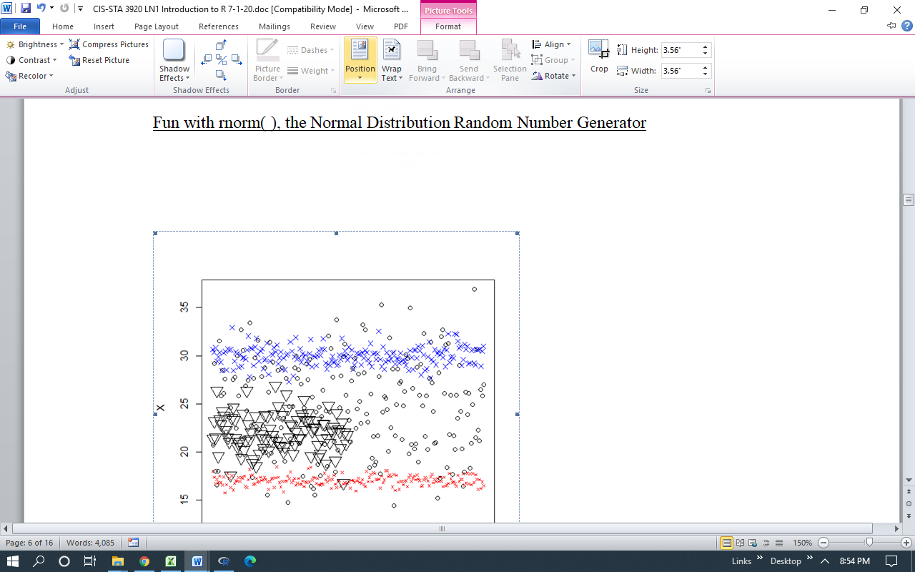
(b) Select a Position, in Wrap Text select Square, then click on Crop and trim;
(c) Adjust the size to be readable and the placement to allow text beside it.
The technique is similar on a Mac.

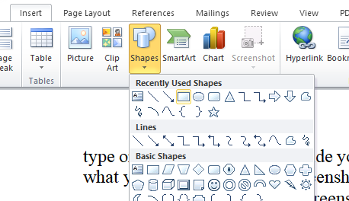
Fourth: Use red ovals or boxes to point the reader to regions of interest, as I did below. To insert a highlighting box, go to Insert, Shapes, and then select a box or oval depending on your purpose. Give it properties needed and slide it into paste. Copy and paste it if you need a second or third. (I left an extra red box, on the left.)

Fifth: Note that I tied the elements together in the figure above, using the Group command. That way, the three red boxes move with the cropped screenshot. You can test that it does. (They should stay linked, but sometimes Microsoft sabotages us when we move a file between older and newer versions of Word. To avoid that problem, I have two tactics: either I switch to pdf files or I copy and paste a grouped figure as a “Picture.” Recently, I find that grouped figures are not allowing text wrapping. Please tell me if you find a fix.)

Sixth: Type your name at the top of the page on the right hand side. I will assigning an index number for each student: show that immediately after your name. On the left-hand side of the top line, put “Baruch College, STA-CIS 3920, Exercise # __. Fill in the number. Put the date of submission immediately below.

Seventh: Spell-check.

Eighth: Do not plagiarize.

Help: When you need R help, I recommend always trying R, itself, as I show in the exercises. With repeated exposure you will slowly get better and understanding how to read it. The other reliable sources are StackOverFlow discussions and sites with edu extensions, which are written by professors. Of course, all of us sometimes pick up useful tips from commercial sites such as Quick-R.

Exercises for Lecture Notes 1

Appendix: Practicing commands
Install R and open it. From Lecture Note 1, practice typing in the commands presented on pages 1-5 and how to save your Workspace on pages 10-11. As you work, change each command at least once, using your own values. Copy and paste the history of that work and put into an appendix to this assignment. Put that Appendix at the end of this assignment, NOT the beginning.

Exercise 1.1: Graphing the standard Normal (Z) density function

(a) The following command plots the Z density function. The Z-distribution has expected value 0 and standard deviation of 1. Try it out. Be careful that you do NOT use the number 1 in the type argument: you need the letter “el,” the letter that comes after “k” in the alphabet; it is short for “line.” If you have trouble, use the command ?plot to get to the help file.
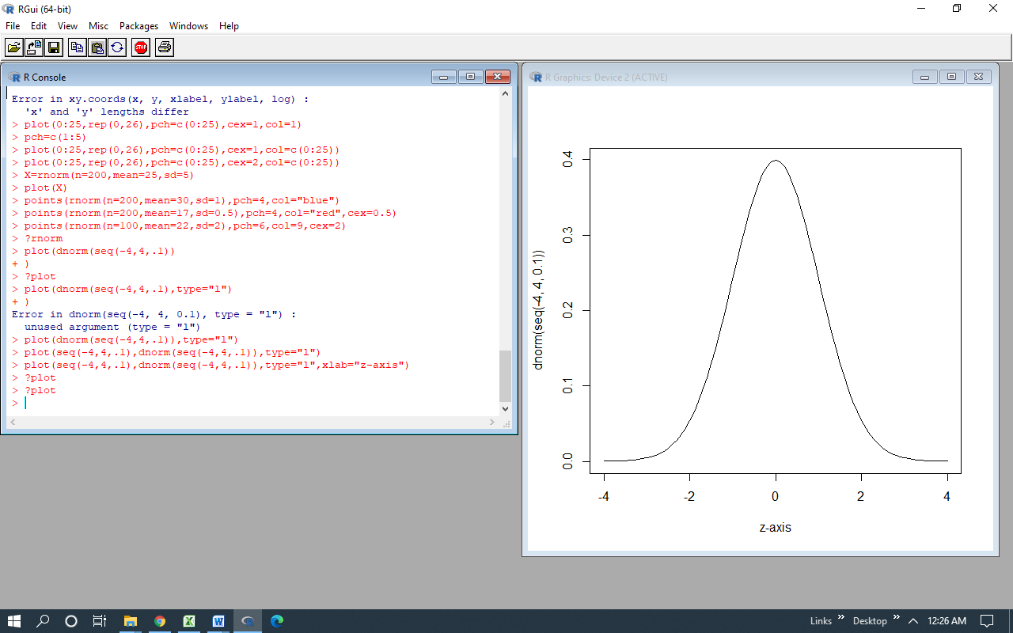

(b) What does the seq function do, above? Explain. Show. See ?seq for help.

(c) Use command ?seq to go to R’s help file on the sequence command. Work out how to use the version of seq shown below to get the same sequence as above. Show your work.
seq(from, to, length.out= )

(d) The following plot command adds a meaningful x-axis label. Try it out. Then, find out how to add an appropriate vertical axis label and main title. Add your name to the title. R supplies some help if you type ?title.

(e) Figure out how to change the color of the line (the bell curve) and of the main title.

Exercise 1.2: Using a histogram to summarize sample points from Normal dist.

(a) Use the following commands to generate 25 z-values and form a histogram. Does the result look surprising? Why?
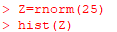

(b) Try using 200 or more points. Is that better? Explain.

(c) By default, R uses too few bins for large sample sizes. Add the argument breaks=seq(-4,4,0.1) and see what happens. Try ?hist if you get lost. Add the main title and include your name in it.

Exercise 1.3: Plotting time series of sample points from Normal dist’s

We can easily generate values from a Normal distribution with any desired expected value and standard deviation. Here, I generate 200 values from a Normal distribution with expected value 25 and standard deviation 5. I then plot them as a time series. Where do the points seem to concentrate in terms of the values, in the vertical direction?
I then use the “points” command to add more points from a Normal distribution with expected value 17 and standard deviation 0.5. I also show how to change the “point character” to tiny dots and the color. Then, I add points from a third Normal distribution with expected value 28 and standard deviation 2, solid circle points, in blue.
Try my version, then come up with your own. How is the expected value reflected in the points? How is the standard deviation reflected?
